Chapter 4, Problem 45.

Find the Thevenin equivalent of the circuit in Fig. 4.112 as seen by looking into terminals a and b.

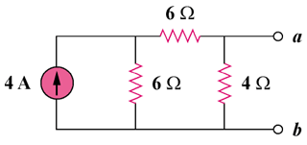

Figure 4.112
For Prob. 4.45.

